Inverse Transformations

These are also called as opposite transformations. If T is a translation matrix than inverse translation is representing using T-1. The inverse matrix is achieved using the opposite sign.

**Example1:** Translation and its inverse matrix

**Translation matrix**

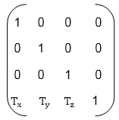

**Inverse translation matrix**

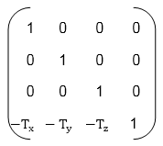

**Example2:** Rotation and its inverse matrix

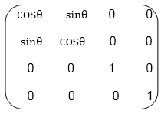

**Inverse Rotation Matrix**

